Glenville GAA Club Newsletter
Volume 2 Issue 7
June 12th 2015
In this Issue
Lotto Results
Under 14 Football Championship Report
Under 10 Football Tournament
Match Reports
Guess the score
Juvenile Training
Upcoming Fixtures
Lotto Results
Our club lotto jackpot has now increased to €3800 as there was no winner from last week’s draw. The winning numbers on the night were 8, 9, 13 & 25. Small Cash prize winners of €20 were Thos Sheehan, Diarmuid Mc Carthy, Kevin Barry and William Connolly. Next week’s draw will take place in Kades.
Saturday June 6th premier 2 under 14 Football Championship
Venue Ballinue
Glenville 5-4
Eire OG 7-14
On Saturday last saw our under 14 footballer’s travelled down north to Ballinue for the first round of the premier 2 football championship. Eire Og was the opposition on a sunny afternoon which saw some lovely football being played. As per usually we played against the light breeze in the first half but it was our opponents who would register the opening two points in the space of two minutes. From the resulting kick out we worked the ball up the field to Sean Desmond who scored the opening goal of the match to put us up by one but the scoring spree didn’t stop there as Glenville would get in for their second goal of the match coming from Rob Mc Kenna which followed moments later with a point. However we were unable to keep up this frantic pace as Eire OG Broke past the Glenville Defence and buried the ball in the back of the net. Once again Sean Desmond was causing havoc for the Eire Og full back line and the combination of Desmond and Ger Heffernan in the forward line set up Rob Mc Kenna for his second goal that was followed later with a white flag been raised thanks to a Davin O’Sullivan point. Eire OG who were always dangerous going forward hit 3-2 without reply but once again the Glenville response was empathic as Sean Desmond got out first to the ball and broke past the Eire Og defence as buried the ball down low to keeper’s right to score Glenville fourth Goal of the game. On form Rob Mc Kenna hit over his second point to leave the scores 4-3 to 4-4 with half time approaching. Eire Og finished the half strong as they hit over the last three points to leave the scores 4-7 to 4-3 at the interval. Eire og purple patch continued in the sound half as they dominated the midfield area out scoring us 3-7 to 0-0 in the apace of twenty five minutes. The Glenville full back line tried the heart and soul out trying to keep the Eire Og forward line from at bay. We finished the half strong thanks to a Conor Gowen point and a James O’Leary goal. In the end Eire OG ran out deserving winners on a score of 5-4 to 7-14. Well done to Eire Og on their win a fair deuce to our lads who kept going right to the very end all played brilliant ye did the club proud. However this is not the end of the championship for the under 14 as now we will go into a plate competition with our opponents and venue Yet TBC.
Saturday June 6th under 10 Football Tournament
Venue Dromtarife
last Saturday 6th of June u10s went to Dromtarife where they played lyre in the first game and won it well on a score line of 3.9 to 0.1 Cian o Callaghan did well in goal Ross Hennessy and Mike O’Driscoll hell the back line solid with Liam Foley, Eanna Fitzgerald and Calum O’Mahony held the centre field tight and with Cian O'Leary and Jake Frayne doing the scoring up front .Fionn Fitzgerald Sam Denhenny Ryan Loftus Jake Frayne putting in a lot of good work.
Next up was Ballyclough this was also a good game where Jamie Curtin Darra Collins were on their game from the start with Ciaran Linehan and Cathal Murray working hard Ben O’Sullivian and Josh O’Sullivan also putting in a good work rate where Glenville came away winners on a score line of 6.5 to 1.1.
In the last game we came up against Kilmurry in this game we had a little bit more work to do and this was where Ciaran O’Riordan Shane O’Callaghan show great team work and worked hard Darra Collins and Jamie Curtin also work well to put this game to bed as quick as possible with great help from Ryan Loftus in this game Glenville won on a score line of 2.9 to 1.2 we will now return this Saturday to play another few games and hopefully do the business.
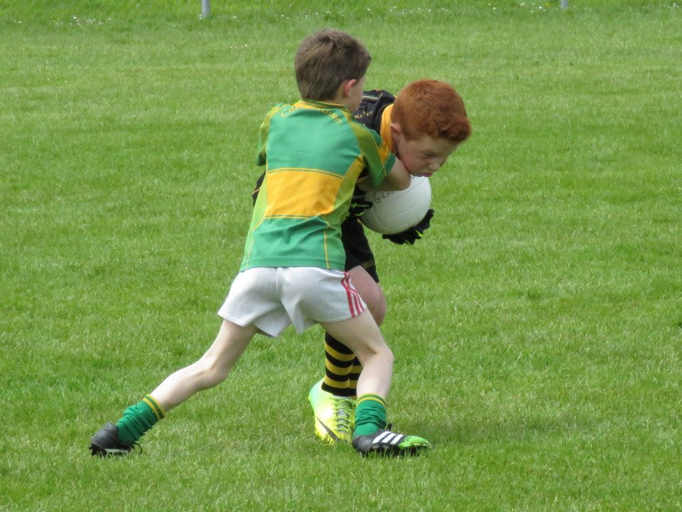
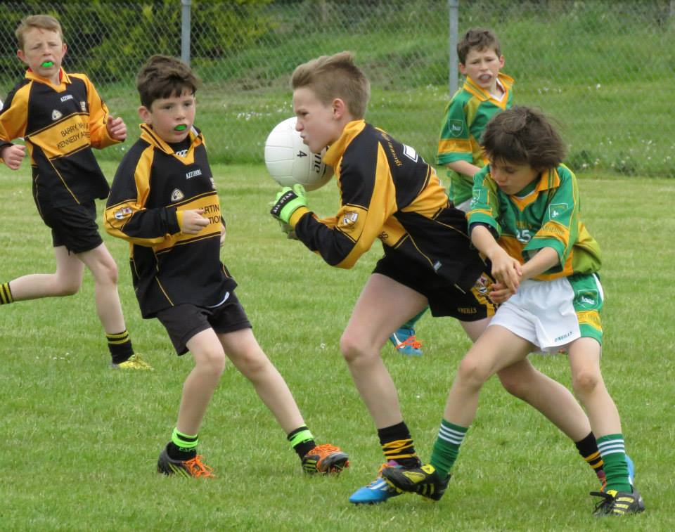
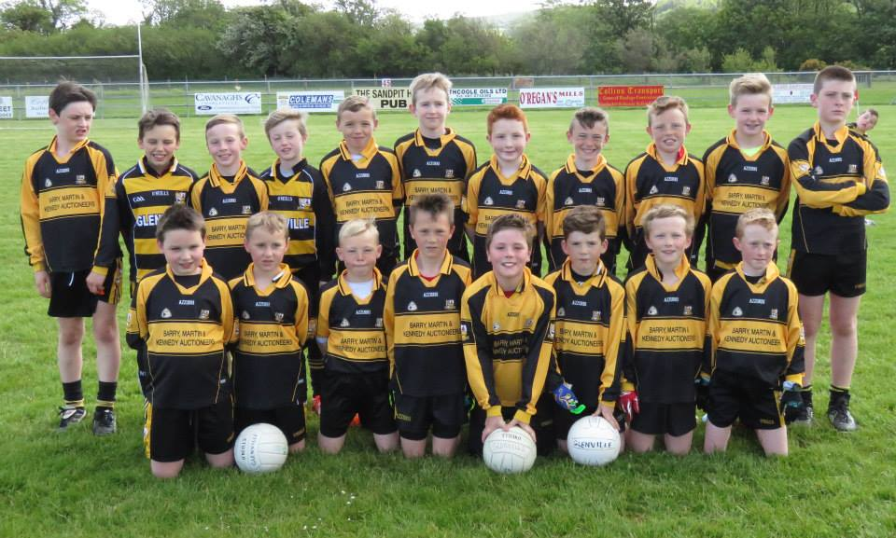
The Glenville under 10 that took part in the recent tournament in Dromtarife

Saturday June 6th under 12 A Football League
Venue Donoughmore
Donoughmore 1-3
Glenville 5-9

Glenville made the journey to mid cork on Saturday to play Donoughmore. Glenville had a slow start to this league losing our first two games and winning our last outing against Erin’s Own, so a win here today was vital.
Glenville had a bright start. Mark O'Donoghue was Glenville's key man in the first 10mins and scored 1:1 in this time to get Glenville up and running. Colin O'Keefe was causing the Donoughmore back line a lot of trouble and picked off a few lovely scores. In midfield Eoin FitzGerald began to take charge, and he made some great runs and Donoughmore had no answer to this. Daniel Cronin was Eoin's midfield partner. He was marking the Donoughmore danger man and had to be on the top of his game throughout. Glenville began picking off the scores very well throughout the first half and a long ball from Colin O'Keefe was expertly deflected into the goal by Ben Flanagan. Liam O'Keefe, who was late to the match due to a SatNav malfunction was introduced early on and was made a great contribution to his team. The score was 3:3 to 1:1 at half time.
Although the forwards were causing havoc throughout the game, it was the dominance of the Glenville backs that was most impressive today. In particular the full back line of Eoghan Knapp and Patrick Ryan was arguably the winning of the game, and this young pair seems to be improving with every game they play. In the halfback line, there was no getting the better of Sean Murphy, Donal Sheehan and centre back Davin Sullivan.
Glenville won well in the end. Colm O'Regan almost scored a spectacular goal late on when he lobbed the goalie only for the ball to rebound off the post. He followed this up with a great hand pass over the bar, a score which would not have looked out of place in Fitzgerald’s Stadium or Croke Park!
Glenville will have a break now for two or three weeks, but will return with and important game against league toppers Kiltha Og.

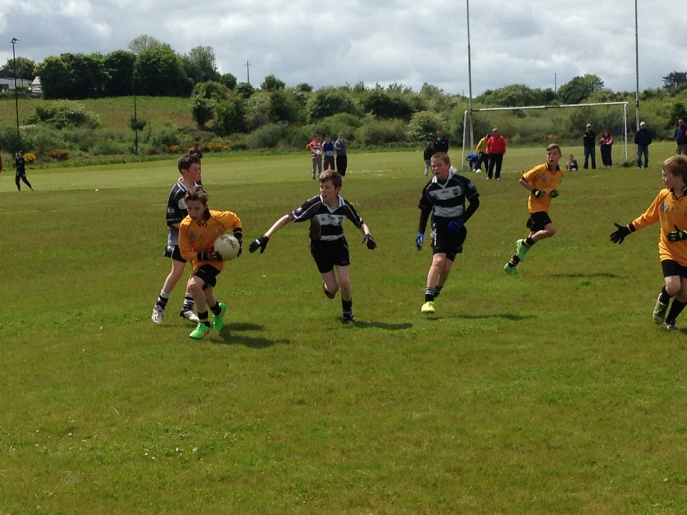

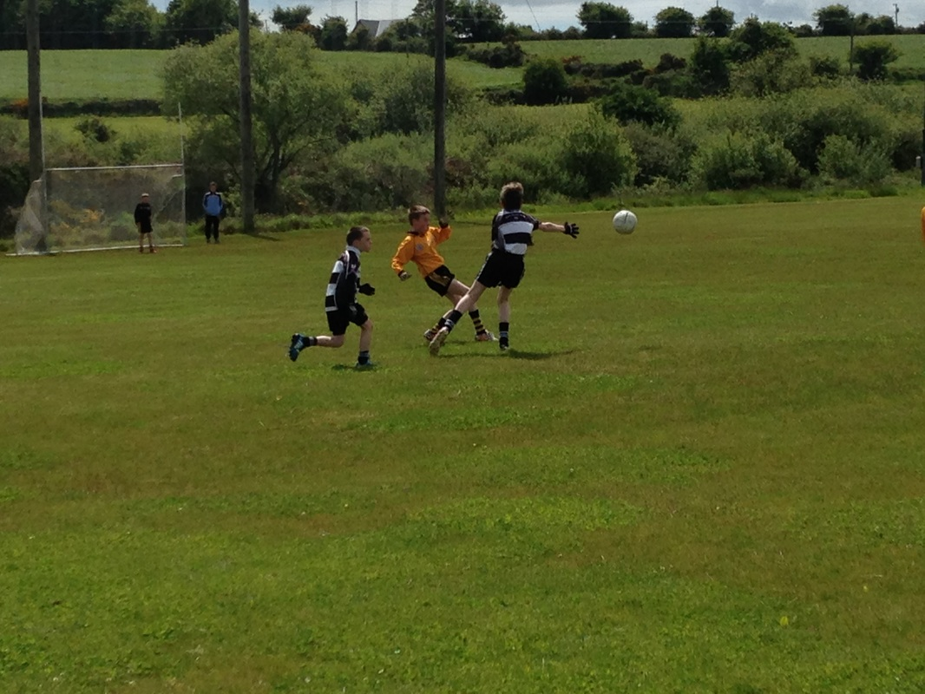

Sunday June 7th Junior B Football Challenge
Venue Glenville
Glenville 0-11
Whitescross 0-12
On Sunday morning last say our Junior B Footballer’s entertain Whites cross in a challenge match. Both teams played out a thrilling match with opposition coming away with a one point victory in the end.
Guess the Score
The Glenville GAA club held a guess the score competition for the cork v Waterford match with the winner receiving €200. There was no winner on the day so a draw took place and congrats to Sean Counihan, Maeve Maloney, Sean O’Driscoll and Jerry Dinan who won €50 each.

Juvenile Training
Juvenile training will continue this Wednesday night from 7-8 in Glenville.
Up Coming Fixtures
Saturday June 13th under 10 Football Tournament in Dromtarife @ 10:30
Sunday June 14th Intermediate Football League v Castletownbere @ 11:30
Email: pro.glenville.cork@gaa.ie
Twitter @glenvillegaa
Facebook Glenville Football Club
Website glenvillegaa.weebly.com

